- Find the folder that you created in the previous step called “home”
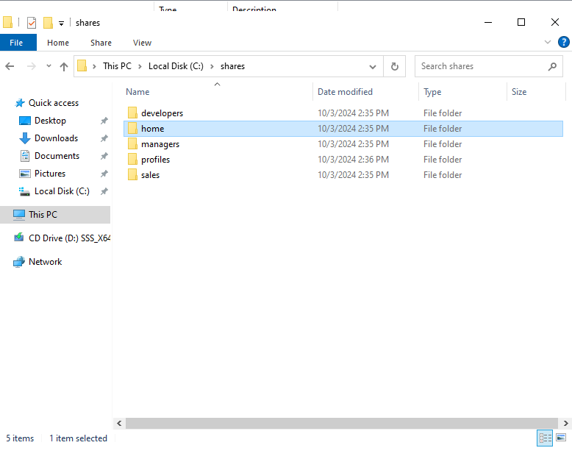
- Right click on the home folder and select properties
- Select Sharing, and Advanced Sharing …
- Check the “Share this folder” option
- Change the name of the share to home$ so that it is hidden from users view.
- Click Permissions, and grant Everyone full control (don’t worry we’ll lock this down later) > Apply > OK > OK (The configuration is shown below – you should now be back at the home Properties dialog box)
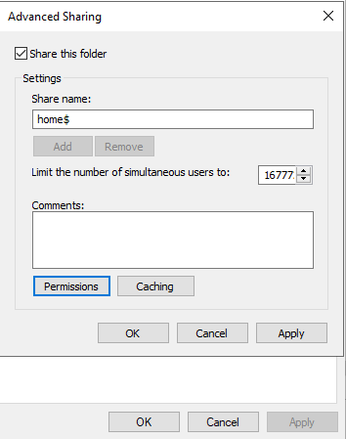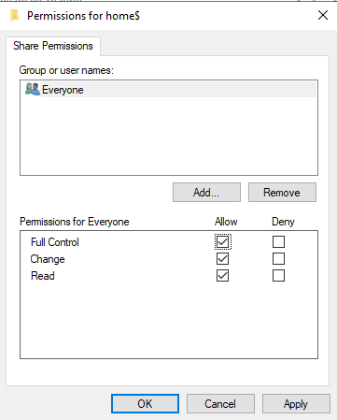
- Click on the Security Tab > Advanced, Click on Disable inheritance and choose “Convert inherited permissions into explicit permissions on this object.”
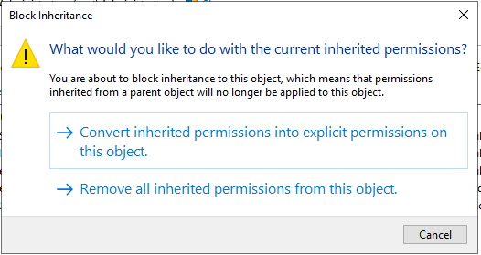
- (Still in the Advanced Security Settings for home): Double click the “CREATOR OWNER”
- Make sure that the “Applies to:” = Subfolders and Files only > Full Control
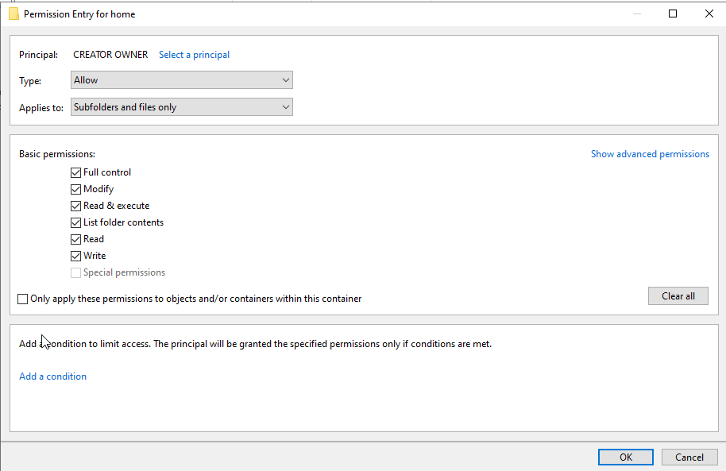
- Check to see if SYSTEM has “Full Control” for “This folder, subfolders and files.”
- Do the same for [DOMAINNAME]\Administrators
- Remove the Users (the one with Read and Execut)
- Remove the Users (the one with Special)
- Add the “Everyone” group. Make the settings as follows:
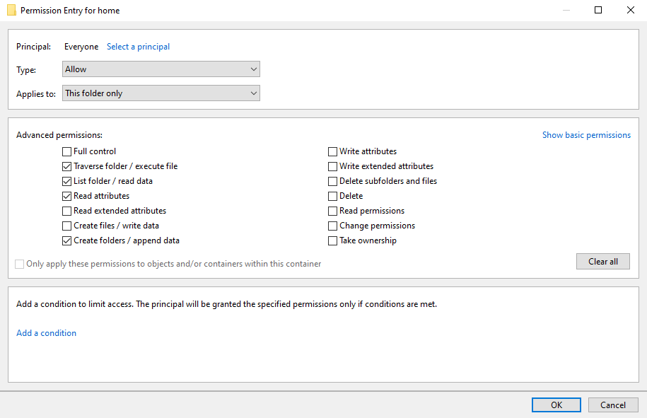
- Click OK… and finally close. To get back to folder explorer.

Allocate the Home Folder to the Domain Users

- From within AD Users and Computers locate your users that we created (Let’s start with Developers)
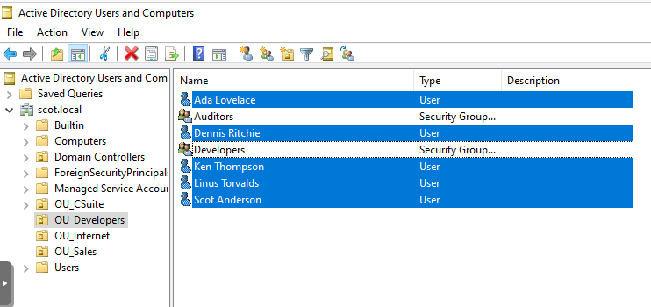
- You can use Ctrl+Click to deselect the groups. Right click and select properties, Profiles
- Check Home Folder, Select Connect, Select H:,
- Set To: “\\CPTR230A\home$\%username%
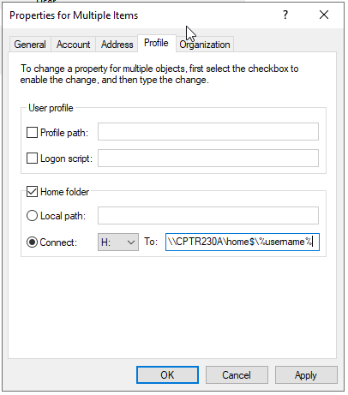
- Click OK.
- Go Check the home folders and you will see that they are created.
- Now, do the same thing for your other users in OU_CSuite and OU_Sales

Creating Roaming Profiles

Instead of creating a new share for profiles, we are going to store them in the \\CPTR230A\home$\%username%\Profiles
- Open the properties for each group of users like before and Check the Profile path: and add the above string.

